# All links are active for given network:

# **1 to 2 tracert**

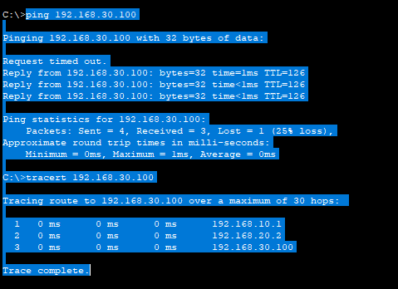

# **1 to 3 tracert:**

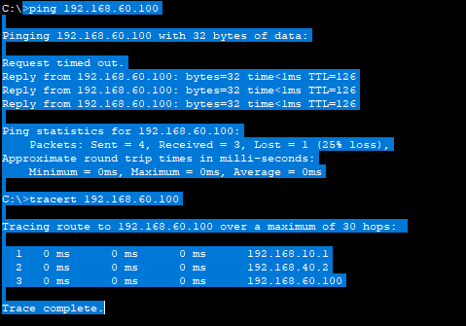

# **2 to 1 tracert:**

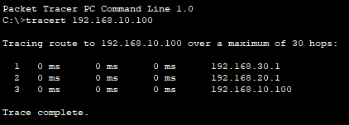

# **2 to 3 tracert:**

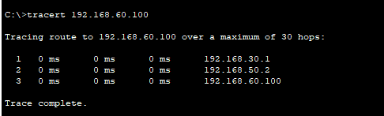

# **3 to 1 tracert:**

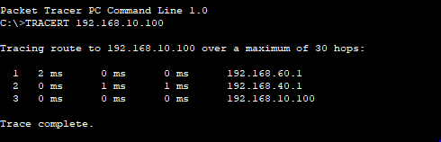

# **3 to 2 tracert:**

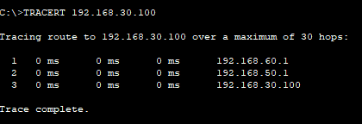

# Down the link between router R1 and R2:

# **1 to 2 tracert**

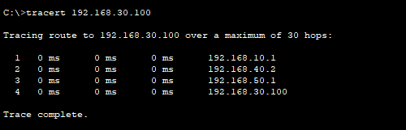

# **1 to 3 tracert:**

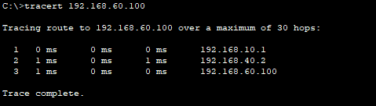

# **2 to 1 tracert:**

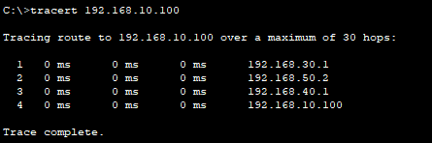

# **2 to 3 tracert:**



# **3 to 1 tracert:**



# **3 to 2 tracert:**



# Down the link between router R1 and R3:

# **1 to 2 tracert**

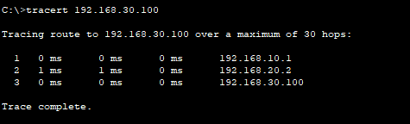

# **1 to 3 tracert:**

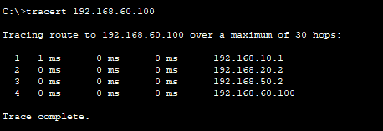

# **2 to 1 tracert:**

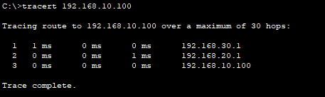

# **2 to 3 tracert:**



# **3 to 1 tracert:**

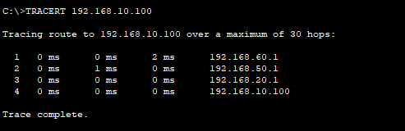

# **3 to 2 tracert:**



# Extract static routes from network and then disable RIP protocol delete network from RIP of each router and perform static routes and check following:

# **1 to 2 tracert**

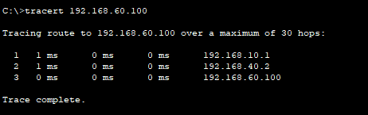

# **1 to 3 tracert:**

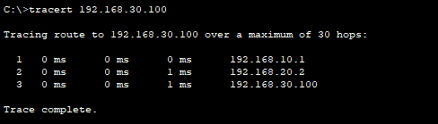

# **2 to 1 tracert:**



# **2 to 3 tracert:**



# **3 to 1 tracert:**



# **3 to 2 tracert:**

